Title: | Door Control Module  SW Component DoorLockingApp

History
Issue status  (Index) | Maturity/Date  (draft/invalid/valid)  (dd-mmm-yyyy) | Author  Department | Check/Release  Department | Description
1.0 | Draft  31-Jan-21 | Marco Antonio Romo Ramírez | - | Creation of the document

Table of Contents
1 Purpose 3
2 Definitions and abbreviations 3
3 Realization constraints and targets 3
4 SW Conceptual design 4
5 SW Component internal breakdown 5
5.1 Functional Decomposition 5
5.2 Function void DoorLockingApp_Decisions_100ms() 6
5.3 Function void AutoLockWhileDriving() 8
5.4 Function void NewDoorLockEven(DoorButtonPressed* DoorLockButton) 9
5.5 Function void NewDoorLockSwitchEvent(Bool* UnlockSwitch, Bool* LockSwitch) 9

Purpose
This document shows the corresponding interfaces of the DoorLockingApp software component. This component will handle all the logic necessary to close or open the doors.

Definitions and abbreviations
Definitions
NA

Abbreviations

SysPwrMode system power mode
ConfortCmd Comfort Command
No Cmd Lock Command
UnlockAllCmd Command for all Doors
UnlockDrvrCmd Unlock Command for Driver Door only
VehSpeed Vehicle Speed
LockingReq Lock or Unlock Request
DoorLockSts Door Lock Status
DCU Door Control Unit
BCM Body Control Module
SW Switch
SWC Software Component
References
N° | Document name | Reference
1 | SW Architecture | Commit:

Realization constraints and targets
The DoorLockingApp component has the target of controlling the locking and unlocking the doors, of the Door control module system.

SW Conceptual design

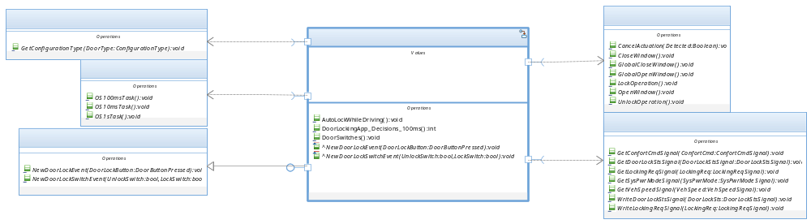

SW Component internal breakdown

Functional Decomposition

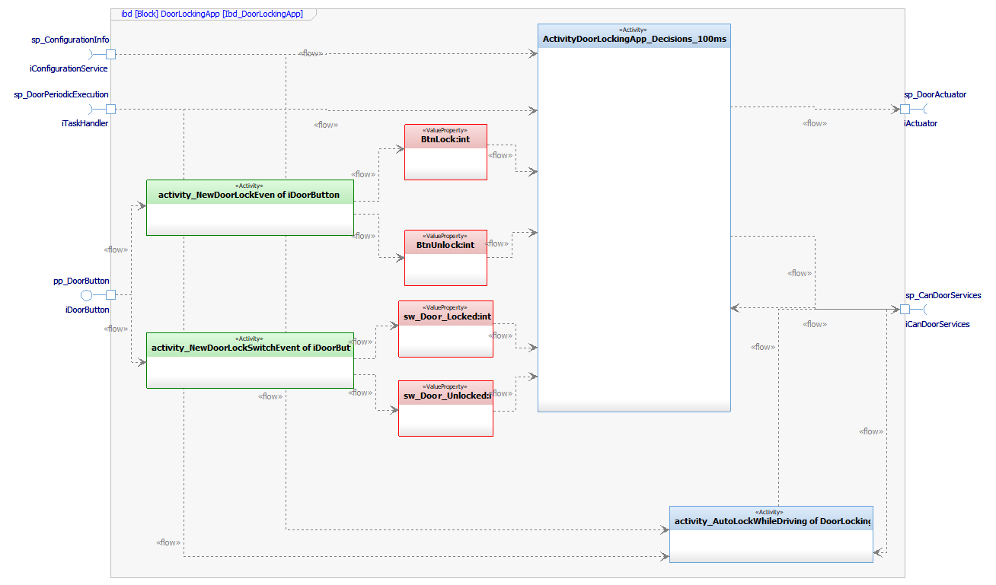

Function void DoorLockingApp_Decisions_100ms(void)

Description | DoorLock App_Decisions_100ms is the main function of the DoorLock App component. The function is used to execute the logic necessary to lock or unlock the door, this function receives variables from the iDoorButton, iCanDoorServices, iConfigurationService, and iTaskHandler interfaces, depending on the data it receives, It is the action performed in response, which is sent through the iActuator interface, to block or unblock a door
Parameter 1  <input| output| inout> | NA – Does not use parameters.
Parameter 2..n | NA – Does not use parameters.
Return Value | NA – Does not return a value.
Precondition | The function depends on "ButtonManager" or "CANServices" to be able to make a decision and perform an action
Post condition | When the “DoorLockApp” function makes a decision, it performs an action in “ActuatorManager”
Error Conditions | If SW_DOOR_LOCKED equals SW_DOOR_UNLOCKED then the system is in an error state
Requirements | NA – Review traceability matrix

Dynamic Behavior
State Chart¹
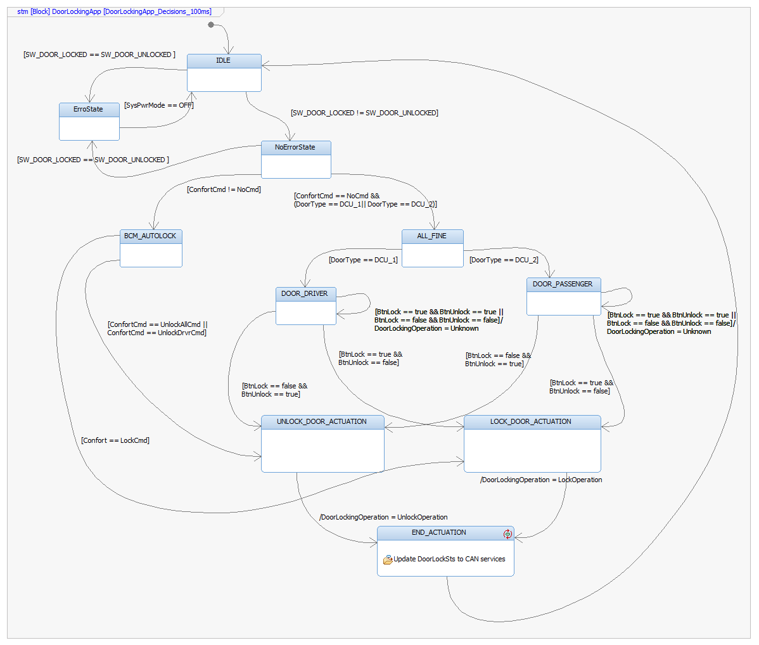

Function void AutoLockWhileDriving(void)
Description | The function is used to execute an Auto Lock. The function receives values from the BCM and depending on these, the function makes the decision whether it should generate a lock request or not, this request can only be sent by the driver's door.
Parameter 1  <input| output| inout> | NA – Does not use parameters.
Parameter 2..n | NA – Does not use parameters.
Return Value | NA – Does not return a value.
Precondition | The function depends on "CANServices" to be able to make a decision and perform an action
Post condition | When the function makes a decision, it must be sent to "CANServices" to be received by the BCM
Error Conditions | NA – Any error condition identified yet.
Requirements | NA – Review traceability matrix

Dynamic Behavior
Flow Chart¹
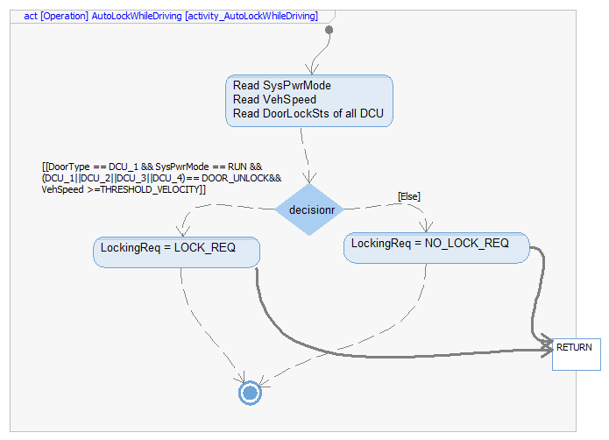

Function void NewDoorLockEven(DoorButtonPressed* DoorLockButton)
Description | This function is call by DigitalInputManager SWC to update BtnLock and BtnUnlock variables.
Parameter 1  <input| output| input> | DoorButtonPressed* DoorLockButton< input>
Parameter 2..n | NA – Does not use more parameters.
Return Value | NA – Does not return a value.
Precondition | SWC shall be initialized first.
Post condition | The DoorLockingApp_Decisions_100ms () function uses the interface information
Error Conditions | NA – Any error condition identified yet.
Requirements | NA – Review traceability matrix

Function void NewDoorLockSwitchEvent(Bool* UnlockSwitch, Bool* LockSwitch)
Description | This function is call by DigitalInputManager SWC to update SW_Door_Locked and SW_Door_Unlocked variables.
Parameter 1  <input| output| inout> | Bool* UnlockSwitch < input>
Parameter 2..n | Bool* LockSwitch < input>
Return Value | NA – Does not return a value.
Precondition | SWC shall be initialized first.
Post condition | The DoorLockingApp_Decisions_100ms () function uses the interface information
Error Conditions | NA – Any error condition identified yet.
Requirements | NA – Review traceability matrix

